***6.2 Transport system***

**6.2.1 Draw and label a diagram of the heart showing the four chambers, associated blood vessels, valves and the route of blood through the heart.(1)**

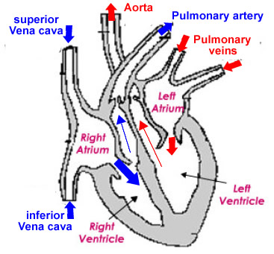

* Each atrium fills with blood from the veins.
* Ventricles are filled with blood from their respective atria.
* Blood exits the ventricles (and heart) in arteries.
* The red arrows suggest oxygenated blood
* Blue arrows represent deoxygenated blood.
* Blood enters the heart under lower pressure in veins, it exists the heart in arteries under high pressure.

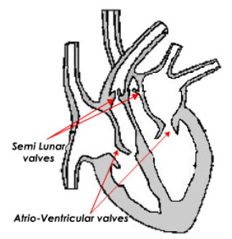***Heart Valves***

* Vales maintain a one way flow of blood.
* Atrio-ventricular vales open to let blood flow from atria to the ventricles.
* The atrio-ventricular valves close to prevent a back flow of blood into the atria.
* Semi-lunar valves open to allow high pressure blood to pulse into the arteries.
* Semi-lunar valves close to prevent black flow of blood into the ventricles form arteries.
* The left atrio-ventricular valve is also know as the bicuspid valve.
* The right atrio-ventricular valve is also known as the tricuspid valve.

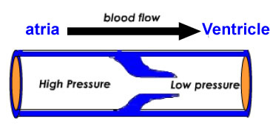

* Pressure of blood to the left is greater than pressure to the right
* Valve flaps (cusps) pushed open.
* Blood flows to the right.

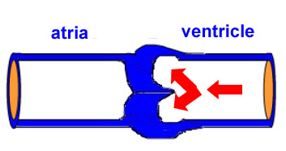

* The pressure on the right is greater than the pressure on the left.
* Cusps pushed closed.
* Back flow stops

**6.2.2 State that the coronary arteries supply heart muscle with oxygen and nutrients.(1)**

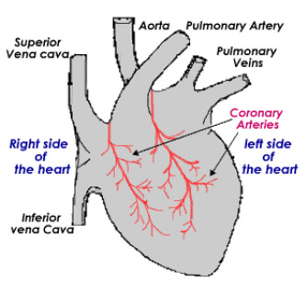

* The heart has its own blood vessels.
* Blood passing through the chambers of the heart does not provide nutrient or oxygen to the heart muscle cells.
* Coronary arteries are branches of the aorta which provide the heart muscle with a supply of oxygen and nutrient.
* The coronary arteries branch and spread through the heart muscle supplying the individual muscles cells.

**6.2.3 Explain the action of the heart in terms of collecting blood, pumping blood, and opening and closing of valves.(3)**

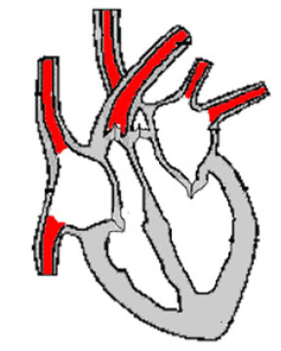

***Diastole***

* The heart muscle is relaxed this is called **diastole**.
* There is no pressure in the heart chambers.
* Blood tries to flow back into the heart but closes the semi-lunar valves.

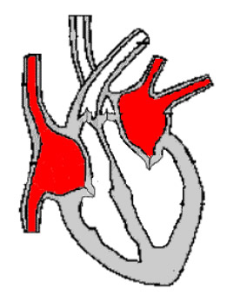

***Diastole***

* Both atria fill with blood returning to the heart in the veins.
* The right atria fills with blood returning in the vena cava from the body tissues (deoxygenated).
* The atrio-ventricular valves are still closed and the atria fill up.
* When the pressure in the atria is greater than the pressure in the ventricles the atrio-ventricular valves will open.

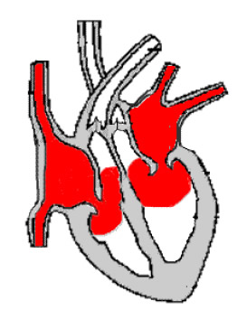

***Late Diastole***

* In this diagram the heart is still relaxed (diastole).
* The pressure of blood returning to the heart and filling the atria is now high enough to open the atrio-ventricular valves.
* The pressure in the atria is greater than the pressure in the ventricles.
* Atrio-ventricular valves open
* Ventricles begin to fill with blood.

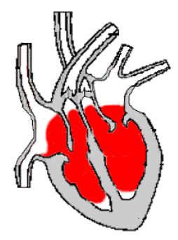

***Atrial systole***

* Both atria contract together (see control of heart rate)
* The muscles of the atria contract.
* volume of the atria reduces.
* Pressure of blood increases
* Blood flow into the ventricle, filling this chamber and causing the ventricle wall to stretch.

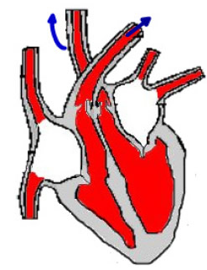

***Ventricular Systole***

* The ventricle contracts (systole)
* The pressure increases in the ventricle
* The atrio-ventricular valve closes
* The pressure rises further
* Pressure in the ventricle is greater than the artery, semi- lunar valve opens
* Blood pulses into the arteries

**6.2.4 Outline the control of the heartbeat in terms of myogenic muscle contraction, the role of the pacemaker, nerves, the medulla of the brain and epinephrine (adrenaline).(2)**

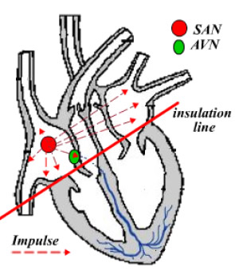

* Myogenic muscle contraction describes the way the heart generates its own impulse to contract. It does not require external nerve input.
* In the wall of the right atrium there are a group of specialized cells(SAN).
* Cells of the Sino-Atrial Node generate an impulse that can spread across the muscle cell of both atria (red pathway).
* The impulse causes a contraction of both atria together.
* The impulse cannot spread to the muscle cells of the ventricles.
* The impulse is picked up by a sensory ending called the atrio-ventricular node (AVN).

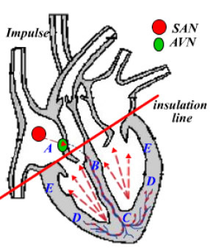  
  
The atria have already contracted sending blood down into the ventricles.

The ventricles are stretched and full of blood.

1. The impulse to contract (generated in the SAN) is picked up by the AVN .
2. The impulse to 'contract' travels down the septum of the heart, insulated from ventricle muscle fibres
3. The impulse emerges first at the apex of the heart. This causes this region to contract first.
4. The impulse now emerges higher up causing this region to contract.
5. This region contract last.

The effect is to spread the contraction from the apex upwards, pushing blood towards the semi-lunar valves.

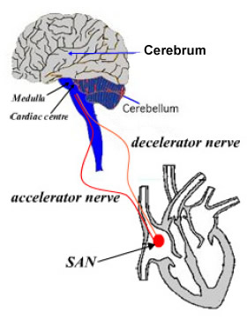

***Modification of myogenic contraction***

The basic myogenic contraction can be accelerated or slowed by nerve input form the brain stem or medulla.

There are two nerves:

* Decelerator nerve (parasympathetic) which decreases the rate of depolarization at the SAN. Note that the synapse releases acetyl choline.
* Accelerator nerve (sympathetic) which accelerates the rate of depolarization at the SAN. Synapse releases nor-adrenaline.

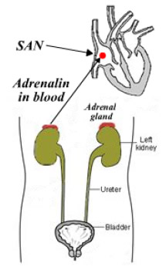

***Epinephrine (adrenaline) and heart rate***

* The hormone epinephrine is produced in the adrenal glands (an endocrine gland).
* The hormone travels through the blood to its target tissue, the sino-atrial node(SAN).
* Epinephrine increases the rate of depolarisation of the SAN.
* This accelerates heart rate.
* This reaction is associated with the 'fight or flight response'.

**6.2.5 Explain the relationship between the structure and function of arteries, capillaries and veins.(3).**

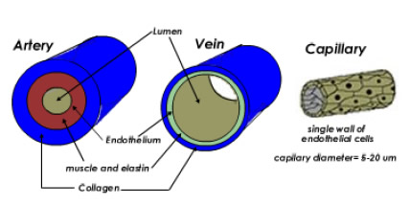a) Arteries have muscular walls and outer layer of collagen for support.

The collagen resists the expansion due to the high pressure of blood.

The muscle layer contracts on the pulse of blood maintaining pressure all the way to the tissues.

b) Veins have carry blood under low pressure the lumen is wide to reduce the resistance to blood flow.

c) Capillaries have only a single layer of endothelium through which exchange can occur in the tissues.

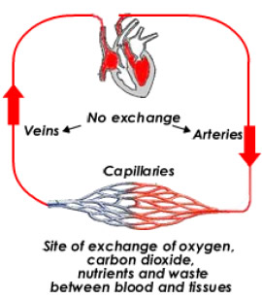

***General functions of arteries and veins.***

Arteries carry blood away from the heart under high pressure.

Veins return blood to the heart under lower pressure.

Capillaries are the site of exchange of blood with tissue fluid and cells.

**6.2.6 State that blood is composed of plasma, erythrocytes, leucocytes (phagocytes and lymphocytes) and platelets.(1)**

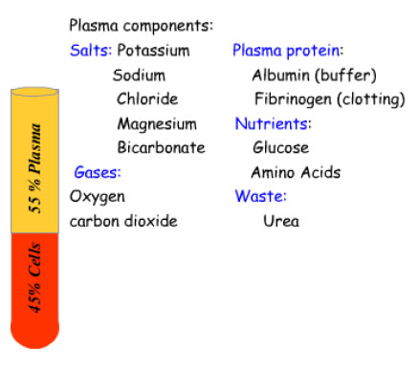

Plasma is largely water and makes up about 55% of the total blood volume.

This is the main transporting part of blood and takes advantage of the solvent properties of water.

The items listed to the left are shown for discussion only.

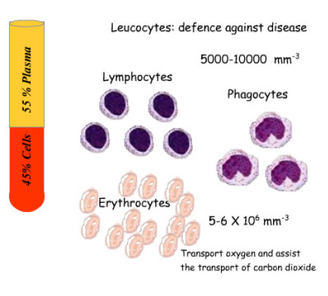

Erythrocytes are the red blood cells.

Leucocytes are the white blood cells

Relative numbers are shown for illustration purposes only.

**6.2.7 State that the following are transported by the blood: nutrients, oxygen, carbon dioxide, hormones, antibodies, urea and heat.(1)**

The items listed above take advantage of the properties of water (as a solvent):

* Nutrients
* Carbon dioxide
* Hormones
* Antibodies
* Urea

or its thermal properties:

* heat

Oxygen and carbon dioxide rely in the RBC for their transport: